Assignment 2:
HTML text formatting refers to the use of specific HTML tags to modify the appearance and structure of text on a webpage. It allows you to style text in different ways, such as making it bold, italic, underlined, highlighted, or struck-through.

INPUT:
<html>
<head>
<meta charset"UTF-8">
<title>FORMATTING TAGS</title>
<body>
<h1>FORMATTING TAGS</h1>
<img src="images/images.jpeg.">
<p>
<strong>Avul Pakir Jainulabdeen Abdul Kalam was born on 15 October 1931</strong>
</p>
<p>
<em>Kalam was the youngest of four brothers and a sister in the family</em>
</p>
<p>
<b>After graduating from the Madras Institute of Technology in 1960</b>
</p>
<p>
<i>During his term as president, he was affectionately known as the "People's President"</i>
</p>
<p>
<mark>On 27 July 2015, Kalam travelled to Shillong to deliver a lecture on "Creating a Livable Planet Earth" at IIM Shillong.</mark>
</p>
<p>
<del>Following his death, the people of India paid tributes on social <media class="sup">2<sup</media></del>
</p>
</body>
</html>
OUTPUT:

FORMATTING TAGS
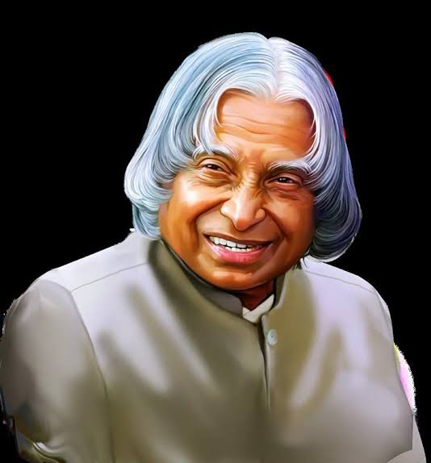
Avul Pakir Jainulabdeen Abdul Kalam was born on 15 October 1931
Kalam was the youngest of four brothers and a sister in the family
After graduating from the Madras Institute of Technology in 1960
During his term as president, he was affectionately known as the "People's President"
On 27 July 2015, Kalam travelled to Shillong to deliver a lecture on "Creating a Livable Planet Earth" at IIM Shillong. 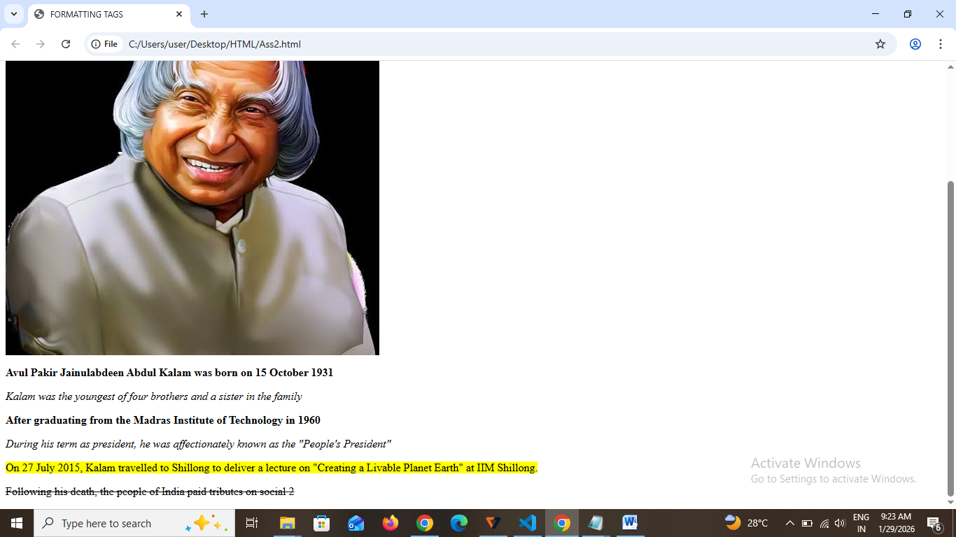
Following his death, the people of India paid tributes on social

